Contact Information:
Graphic Security Systems Corporation
4450 Jog Road, Lake Worth, FL 33467
dpainter@graphicsecurity.com
+(561) 966-0501

Press Release
May 24, 2023
Graphic Security Systems Wins Contract Award for US Passport Card
The Department of State Selects GSSC to Provide Security Features for the Passport Card
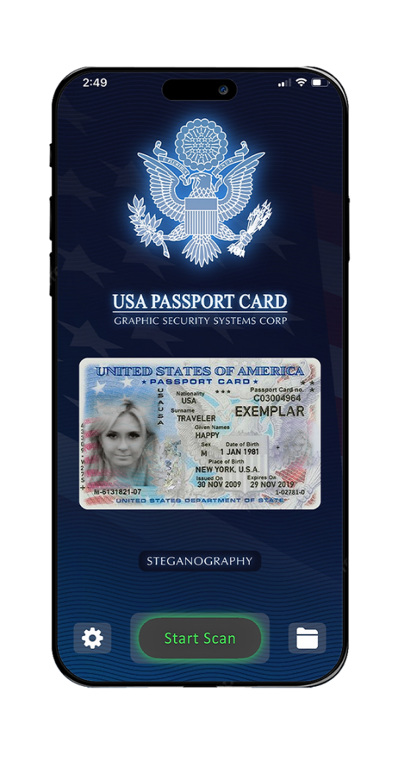
Graphic Security Systems Corporation (GSSC) has been selected as a sole source provider by the U.S. Department of State (DoS) to supply steganographic technology and software for the U.S. Passport Card. This decision is part of the DoS' ongoing efforts to enhance the level of security and fraud-detection capabilities for this important travel document. Furthermore, GSSC has developed a smartphone application that is dedicated to authenticating the encoded features embedded within the Passport Card. This app simplifies the verification process, making it easier and more accessible for border control and other authorized government users.
With over 40 years of experience, GSSC is a leading provider of steganographic technology to government agencies, security printing firms, and major corporations. The company owns 27 U.S. patents and numerous other patents worldwide in the steganographic field, covering a range of software including embedding, scrambling, hiding, encoding, and decoding, as well as optical and digital authentication methods and devices.
Headquartered in Lake Worth, Florida, GSSC is a respected company that is known for its innovation and excellence in the steganographic field. DoS' selection of GSSC is a testimony to its proficiency and reputation for providing high-quality, dependable, and secure solutions.

For more information, please visit www.graphicsecurity.com

